Shabbos Stories For
Yom tov pesach 5785
Volume 16, Issue 29 15-22 Nisan 5785/April 13-20, 2025
Printed L’illuy nishmas Nechama bas R’ Noach, a”h
For a free subscription, please forward your request to keren18@juno.com
Past emails can be found on the website – ShabbosStories.com

The Disappearing
Words of the Haggadah
From the Desk of Yerachmiel Tilles


From the famous Sarajevo Haggadah, circa 1350 (5110)

LEIBEL, like most Jewish shoemakers of the time, was a poor man that lived humbly and did his best to do 'a good job.'
One day his mazal changed. An officer of the Czar's army, on his way back to join his unit, rode through town where Leibel lived and worked. Upon noticing Leibel's shoe repair shop on one side of the street and a tavern on the opposite side of the street, an idea jumped into his mind. So, he immediately dismounted and went in to see Leibel. "I want you to fix my boots and shine them up. Come with me to the tavern. I'll give you my boots and you can bring them back to me as soon as you're finished. Make sure you do a good job, or else."
Leibel followed the officer into the tavern, took the boots back to his shop and very carefully cleaned and polished them until they shone like a mirror.

Very Impressed by the Jewish Shoemaker;s Work
The officer, in the meantime had a few drinks and was happy to see Leibel come in with his boots, especially since his feet were getting cold. He took the boots and looked them over. He was very impressed with the Jewish shoemaker’s work. The boots were so beautiful, they would surely be the envy of his fellow officers. He paid Leibel handsomely and thanked him over and over.
A few weeks later, when the officer happened to again pass through Leibel's town, he had Leibel make him a new pair of boots. This time, he was even more pleased and mentioned that he would tell his fellow officers of Leibel's craftsmanship.
It wasn't too long before a stream of officers found their way to Leibel's shop. Soon, all of the officer's wanted a pair of Leibel's boots and so he became the official boot maker to the czar's army.
It seemed like a miracle to Leibel. For his entire life he had been so poor and now he was getting richer every day. He built a beautiful home surrounded by a large garden and a high fence. Soon he had everything he had ever dreamed of: family, money, and a beautiful home.

No Longer a Simple Shoemaker
Meanwhile his esteem in the community rose accordingly. He was no longer a simple shoemaker but a successful and highly respected manufacturer. All of the local townspeople, looked up to him. They started to come to him for advice and help. He was invited to be on important town committees and honored in his shul.
Actually, Leibel was still an ordinary person, but all the respect and flattery got to him. As his money and honor grew, he believed that he was getting wiser. Before the change in events, he was a quiet humble man; now he was a haughty boor.
One more thing that grew along with his wealth was his paranoia. Sadly, Leibel was always fearful that everyone was scheming to take his money. And day-by-day, his fear about this grew. More and more Leibel stayed away from the townsfolk. He discouraged visitors to his home. He even kept two guard dogs to protect himself from unwanted visitors.
At that time, the Baal Shem Tov's name was spreading over the region. Many people spoke of his holiness and his caring and love for his fellow Jews. To many, just hearing his holy name was an inspiration. Leibel began to meet more and more people who had gone to see the Baal Shem Tov. Often they would ask him if he had met him yet.
"Who's the Baal Shem Tov and why should I bother to go and meet him? I'm probably just as important as him if not more so," Leibel thought to himself. However, he did notice that people were really impressed to meet anyone who had met the holy Baal Shem Tov in person. So, he decided that it wouldn't be a bad idea to be able to say that he had actually met him.

Spending the Last Days of Pesach with the Baal Shem Tov
As it happened, Leibel found himself in the vicinity of Medzibush during the last days of Pesach and he decided to stay there for the remainder of the holiday.
On the sixth day of Pesach, he went to the Baal Shem Tov's shul. There he found a crowd of chasidim, some praying, some studying and some sitting around singing, telling stories about the Rebbe and discussing his teachings.
They welcomed him warmly and invited him to join them at the table. But no one made a fuss over him. Actually, they seemed rather simple to him and he felt a bit out of place. They told him that the Baal Shem Tov would soon come to learn with them, and so he decided to stay.
Suddenly, all the chasidim stood up in silence as the Baal Shem Tov entered the shul. As soon as the Baal Shem Tov sat down at the head of the table, they all quickly crowded around to catch every one of his words. Leibel found himself at the edge of the group of chasidim. It had been quite a while since the last time that he was treated just as an ordinary person and this made him feel a bit uncomfortable. He had grown accustomed to being honored and he actually liked receiving attention. It was strange for him to be among these chasidim.

How One’s Prayers May Not Ascend to Heaven
After singing a niggun (melody), the Baal Shem Tov started to teach an idea about the Torah. Leibel listened in but he did not really understand most of what he heard. He did, however, catch one idea, but it made no sense to him. The Baal Shem Tov said that it is possible to say one's prayers and yet the prayers may not ascend to heaven for a long time. It is entirely possible that the prayers of one who prayed at 10:00 o'clock in the morning should reach the Ribono Shel Olam (“Master of the World”) before the prayers of one who had prayed much earlier in the day.
"That makes no sense at all," Leibel thought to himself.
The Baal Shem Tov continued, "There are some Passover 'Seder' recitations and prayers that have yet to ascend to heaven, even though they were said five days ago." Leibel did not listen much after that; he was baffled as to why so many people were giving this man so much attention, especially since he didn't seem to say anything that made much sense.
"Why did I bother coming here, I should just have stayed home, Leibel thought. “There is nothing special about this man and he says these foolish things. Can it be possible that the words I said at my seder have not yet reached Heaven? How ridiculous! And just look at these chasidim, pushing around their master, just to hear silly ideas!"
It was too late for him to get home for Yom Tov, and so he resigned himself to being with the Baal Shem Tov and his chasidim for the last two days of Pesach.

A Very Tense and Very Different Type of Praying
Leibel found that praying with the chasidim was very intense and very different from anything he had ever experienced. They sang, they cried, they were loud and they were silent, they danced, they 'shuckled' (rabidly bent forward and back) often and fervently - they seemed uninhibited. Here he had no choice but to eat simple food and sleep in a simple home; he missed the luxurious comforts of his own home.
The Baal Shem Tov had instituted a custom that is practiced to this very day- Moshiach's Seudah. About two hours before the end of Pesach, chasidim have another meal at which we eat matzah and drink another four cups of wine with much singing and dancing in honor of Moshiach and the ultimate redemption; may it come quickly in our days. Leibel had never participated in such a meal, and frankly he was already anxious for the holiday to be over so that he could run out and find some bread to eat. But these chasidim were in no rush, in fact it seemed as if they would be much happier if Pesach wouldn't end.

Only Leibel was Looking Around
At one point in the meal, the Baal Shem Tov and the chasidim sang a very hauntingly, beautiful niqun and everyone went into a deeply introspective and high spiritual place. Everyone's eyes were shut and only Leibel was looking around.
In the midst of the niggun, the Baal Shem Tov put his hands on the shoulders of those who were next to him, and they did likewise. It became very quiet. Leibel, as unaccustomed as he was to all of this, did sense that something extraordinary was taking place and without much thought, he too shut his eyes and placed his hands of the shoulders of those who were next to him. It was not long before he began to have his first-ever spiritual experience.
Leibel felt as if he was transported to a heavenly sphere and he was seeing a replay of his own Seder--what had actually happened on the first night of Pesach. Leibel had gone to shul and knowing that it was customary to invite the needy to one's Seder, he approached two wayfarers and invited them. He didn't introduce himself to them, he just said "You and you, you'll be my guests tonight," and then he went to his seat at the front of the shul. He didn't really want any guests, but it was the respectable thing to do. In fact, he finished the prayers before everyone else and went home alone. When the services were over, the two wayfarers waited for their host.

The Shamash Saw the Two Forlorn Fellows
The shul was already empty and the shamash (attendant) was about to close up. He saw these two forlorn fellows and asked them if they had been invited anywhere. They told him that someone had indeed invited them but they did not know who it was. They described him as best as they could.
"It sounds like you're going to Leibel's home. I'll tell you how to get there, but be careful!" the shamash told them. He didn't explain, but he was thinking about Leibel's vicious dogs.
Leibel had gone home before everyone else and had already started his seder as his two guests were still finding their way to his home. He had already made Kiddush and was about to say the opening lines of the Haggadah, "Ha Lachmah Anya-- This is the bread of affliction that our ancestors ate in the land of Egypt. All who are hungry, let them come and eat, all who are needy let them come and join us in,..." just as his two guests were about to open the gate.

The Actions of Leibel’s Guard Dogs
And then Leibel saw himself sitting at his Seder table and the words and letters of “Ha Lachmah Anya” leaving his mouth and beginning to ascend to Heaven. Suddenly one of his guard dogs jumped up and with a great snarl snatched the word "Ha" right out of the air and devoured it. And then the second dog ferociously leapt up and snatched the word "Lachmah" before it rose and it too devoured the word.
And so it was with every word that he said. Why? Because at the very moment that he was reciting the words of the Haggadah about inviting the poor and needy, his two guard dogs were ferociously attacking his poor guests. The guests barely got away and ran for their lives.
Now Leibel realized what the Baal Shem Tov meant when he said that some the words of the Haggadah recited at some Seders had never ascended to Heaven. He grew faint and passed out on the floor. The chasidim revived him.
Later that evening, during a personal meeting with the Baal Shem Tov, he humbly asked for guidance in doing tshuvah (repenting and returning to better behavior). He felt very embarrassed to look at the Baal Shem Tov, but the Rebbe's love and words of encouragement restored his confidence.
Needless to say, Leibel came home a much humbled and joyous servant of G-d Al-mighty and from that time on, he was a faithful follower of the Baal Shem Tov.
Source: Excerpted by Yerachmiel Tilles from the free adaptation by Tzvi-Meir Cohn on his website, baalshemtov.com, based on a story told by Rabbi Sholom Brod.
Biographical note: Rabbi Yisrael ben Eliezer [of blessed memory: 18 Elul 5458- 6 Sivan 5520 (Aug. 1698 - May 1760)], the Baal Shem Tov [“Master of the Good Name” often referred to as “the Besht” for short], a unique and seminal figure in Jewish history, revealed his identity as an exceptionally holy person, on his 36th birthday, 18 Elul 5494 (1734), and made the until-then underground Chasidic movement public. He wrote no books, although many works claim to contain his teachings. One available in English is the excellent annotated translation of Tzava'at Harivash, published by Kehos.
Reprinted from the 2022 Pesach email of KabbalaOnline.org, a project of Ascent of Safed in Israel.

Preparing for the Passover Seder

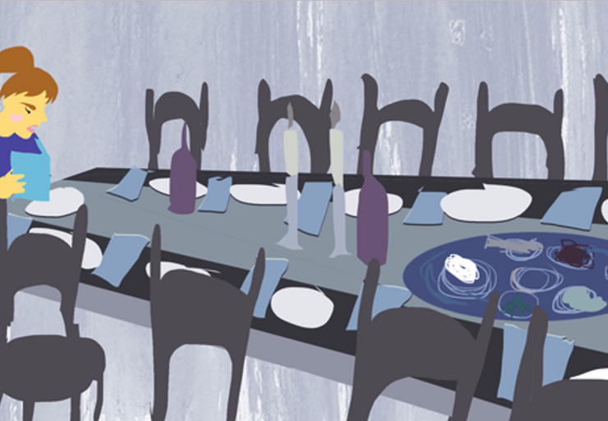
Reprinted from the Pesach 5780 email of Rabbi David Bibi’s Shabbat Shalom from Cyberspace.

Rescue Before Pesach
By Simcha Raz



Rav Aryeh Levin saves 60 Jewish Immigrants It was the day before Pesach in 1939, just hours before the Seder. The British authorities in Palestine had detained sixty illegal immigrants from Iran and thrown them into prison alongside the Jewish underground fighters. With Pesach fast approaching, a Seder was held that night, and special food packages, provided by the community council, were shared by the 40 political prisoners and the 60 immigrants.
However, despite the festive occasion, a heavy sense of worry hung over everyone. No one had arranged sureties for the release of the immigrants, and they faced the grim prospect of being sent back to Nazi-occupied Europe in just six days.
The next day, when R’ Aryeh Levin, the tzaddik of Yerushalayim, visited the prisoners to join them in their tefillos for Yom Tov, they poured out their concerns to him. He reassured them not to worry, but the prisoners were skeptical. How could R’ Aryeh possibly arrange for sixty sureties in such a short time? The deadline was looming, and time was running out. But by noon, the prisoners were astounded.
To their amazement, several hundred people had gathered in the prison courtyard, and one by one, the sixty immigrants were released. It was a miraculous sight—those who had been facing certain deportation were now free. The following Shabbos, when R’ Aryeh visited again, the prisoners eagerly gathered around him, burning with curiosity. How had he managed to pull off such a feat?
With his characteristic calm, R’ Aryeh explained, “As soon as I left you, I went straight to Yeshiva Etz Chayim, where I asked the older students to fan out across the city. I instructed them to go to every Bukharian shul and announce to the congregations about the sixty new arrivals in prison, urging them to come immediately to secure their release. I specifically sought Bukharian Jews because the detainees came from the same region, and I knew the authorities wouldn’t believe they were related to Ashkenazim. And that’s all there is to it.” (A Tzaddik in Our Time)

Reprinted from the Parshas Vayikra 5785 email of The Weekly Vort.

Feeding the Next Generation



Pre-Pesach, 1945, in Bergen-Belsen.
The Bluzhover Rebbe had an unstoppable teshuka to eat matza on the leil ha’seder. Out of his great ahavas ha’mitzvos, he approached Haus, the Nazi Gestapo, to get permission for them to bake matzos. He presented his offer on behalf of 40 people who were willing to forsake eight days of bread in exchange for the deal.
The Gestapo complied, but he added that he would only grant permission if he got approval from his commander. “In Germany, we are very civilized,” explained Haus. “Nothing can be done without permission.”
Three weeks after he sent off the request, he got a letter from his commander enabling them to bake matzos. A mofeis. An hour after they started, Haus the Gestapo stormed into the barracks where they were baking, burning in anger. He ran over and kicked their makeshift oven. Haus explained that he’d learned of a letter that had been prepared to be sent to the Swiss government, detailing what was happening in the camps.
“Is this what you give me,” Haus thundered, “after all the care that I’ve given you?” It was over. There was no more baking. They’d lost their chance. Haus took the matzos, threw them on the floor, and trampled them with his big leather boots. He then went ahead and gave them all a hard beating, leaving his worst blows for Rebbe.
While the Rebbe was being beaten, lying almost unconscious, the Rebbe managed to grab hold of a small piece of matza, tucking it beneath his clothing to preserve it for the seder night. The Rebbe, who at the time was already 56-years old, miraculously survived the beating.
At their secret seder, they all gathered around the Rebbe as he recited the Haggadah in the corner. They’d gathered their water, what the Nazis called “coffee,” and used that as their “daled kosos.”
The matza was whatever had been salvaged after Haus’s rampage, and they certainly had plenty of marror. Kiddush began with the Rebbe’s face beaming with joy and continued with the rest of the Haggadah. The understanding was that the matza would be eaten by the Rebbe, as he was the one who had initiated the baking.
As they reached Motzi Matza, the Rebbe was approached by Rebbetzin Bronya Kashski, requesting that the matza be given to her son. “All the adults here have already eaten matza in their childhood,” she said. “They’ll have that memory for the rest of their lives. But here is a child who has never tasted it. Precedence should be given to him. After all, this Yom Tov is about the children. He hasn’t experienced eating a matza, and so he won’t have any recollection of that auspicious mitzva to renew again when he’ll be freed. Priority should be given to him.”
The Rebbe agreed that her son would be the one to consume that matza. As the boy uttered his bracha, “al achilas matza,” the room filled with emotion and uncontrollable sobbing.
A while after the war was over, Reb. Kashski was redt a shidduch. Before proceeding with it, she went to consult with her daas Torah — the Bluzhover Rebbe. She told the Rebbe that she was redt to someone named Yisrael Spira, and she wanted the Rebbe’s consent. The Rebbe confirmed that the prospective husband was befitting for her, and that she should go ahead with it.
At the appointed meeting, she was shocked. The person who showed up was — the Rebbe himself! His name was Reb Yisrael Spira, and Reb. Kashski hadn’t known his first name.
During the war, the Rebbe had lost his first wife (and only daughter), and she was the prospective shidduch that was suggested. Within a short time, they got married, and the Rebbe raised all her four children. A while later, the Rebbe explained what he found striking in the shidduch. While many people in the camps were sinking in their present trauma, her head was in their redemption. She didn’t get caught in the present darkness, rather she had the authentic emuna that Hashem Who took us out of the Mitzrayim will take them out of that galus. That is who he wanted as a wife.
And over the next 40 years, the Rebbe raised her children as if they were his own. After the Rebbe was nifter in 5750, his stepson, the one who ate that matza, filled his position and continued on his legacy. The Rebbe gave up his matza to transmit the mesora for that boy, and then that boy was the one to transmit the mesora of the Rebbe.

Reprinted from Issue #202 of Rabbi Moshe Hirschberg’s email Zichru Toras Moshe.

Jewish World War II G.I. Enjoying a Passover Matzah

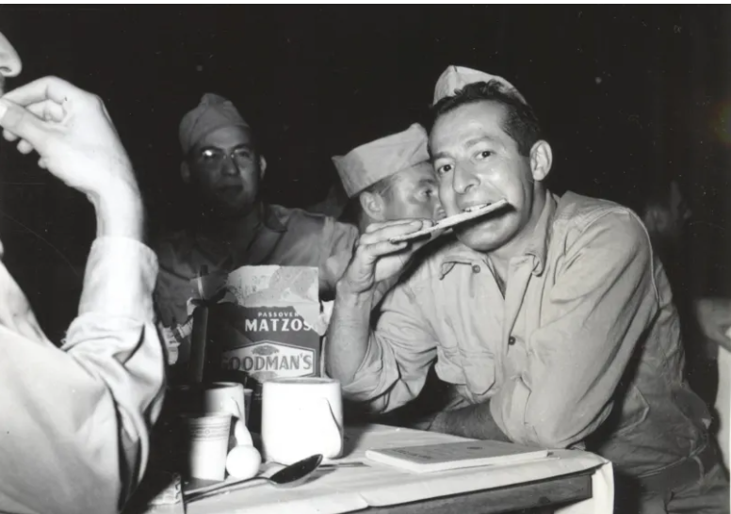
A soldier in Assam, India, enjoys his Passover Matzos (unleavened bread) at the services held for the Jewish enlisted men, officers, nurses, and civilians at the 20th General Hospital. ARC club near Margherita, Assam, India. March 28, 1945.
Food for Thought
By Aharon Spetner

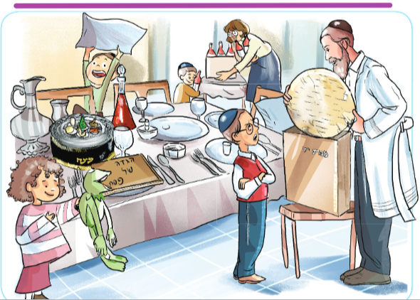
Illustrated by Miri Weinreb

“Gut Yom Tov!” Totty said warmly as he and the boys walked into the house after Maariv.
It was Leil Haseder and everything seemed to sparkle. The table was set with a pristine tablecloth, the kaarah was already in place, and Mommy and Ashi were busy bringing out bottles of wine and grape juice.
“This pillow is mine!” Eli said, proudly putting a pillow on his chair.
“Look Totty!” said Brochi, holding up a stuffed toy frog. “I brought a turtle for makas tzfardeia!”
“Wonderful!” Totty said, taking down a box of matzah from on top of the bookcase. “But that’s a frog, not a turtle.”
Brochi stared at her frog. “I don’t have a turtle,” she said sadly.
“That’s okay Brochi,” Mommy said. “Makas tzfardeia was frogs, not turtles.”
Brochi looked confused. “Then which makah was the turtles?”
“I don’t think there was any makah of turtles,” Totty said. “Unless there were giant snapping turtles during makas arov.”
“The Hagaddah says that there were actually 50, 200, or 250 makos in Mitzrayim,” said Boruch. “Maybe one of them was turtles.”
“Very good, Boruch!” Totty said, carefully removing a matzah from the box and making sure it was shaleim.
“You mean there actually was a makah of turtles?” Asked Boruch, surprised.
“I actually have no idea,” Totty said with a smile. “I just meant I’m proud of you for knowing so much about the Hagaddah.”
“Totty,” said Boruch, his smile suddenly gone. “What kind of matzos are those?”
“These are from the Markowitz Matzah Bakery,” Totty said, laying three matzos on the table and covering them.
“But we always get Horki Matzos,” Boruch protested. “They are the best-tasting matzos in the whole world! Not too hard, not too soft, and they never taste burnt!”
“My morah said that matzah tastes like whatever you want it to taste like,” said Brochi.
“Brochi, I have a feeling you’re thinking of the mann,” said Mommy.
“No, my morah said matzah. She said it falls down from shomayim and Moshe Rabbeinu hit it with a stick and water came out of it.”
“Boruch,” Totty said. “I was not able to get Horki Matzah this year. But Markowitz Matzah is also very tasty.”
“How do you know?” asked Boruch.
“Because I went with a chaburah to bake at the bakery and I ate some of the broken matzos for lunch,” Totty said.
“Wow, kinderlach!” Mommy said. “We are going to eat matzos that Totty baked himself! Isn’t that amazing?”
“No,” said Boruch, crossing his arms stubbornly. “If it’s not Horki, I’m not eating it.”
“Boruch,” said Totty. “You’re a very smart boy. You already showed that you know the Hagaddah. And in the Haggadah there is also a smart boy. Do you know who that is?”
“The chochom,” Boruch muttered.
“Very good! And what is the question that the chochom asks?”
“He asks, “What are these eidos and hukim and mishpatim that our G-d commanded you?” answered Boruch.
“Excellent!” Totty said. “Let me ask you, what are eidos?”
“Testimonies?” Boruch guessed.
“Right again! But testimony is usually found in a courtroom, when a witness makes a statement to the judge. Why, when we are talking about the food we eat at the seder, is it referred to as ‘testimony’?”
This question seemed to stump Boruch.
“It’s because the matzah is telling us something,” Totty said. “We don’t just eat matzah because it’s crunchy and tastes good. Of course we should enjoy eating the matzah, but that’s not the point. Testimony is something very important. And when someone tells you something important, we have to think about it. The point of the matzah is to make us think. As we chew the matzah we need to think about how we were slaves in Mitzrayim, how Hashem took us out, what would be if we had never left Mitzrayim, and more. There is no end to the things we should be thinking about when we eat the matzah.
“How sad is it if someone only eats matzah for the taste and never spends a minute thinking about it? So maybe this matzah isn’t as good as Horki Matzah - and maybe it’s even better - we’ll find out by Motzi Matzah when we eat it. But Hashem wants us to take so much more out of the matzah than just the taste. The matzah is a vehicle and we’re going on an exhilarating ride! So, hop in and let’s see where the adventure of the seder takes us!”
Boruch smiled sheepishly. He felt silly that he was making such a big deal about which bakery the matzah came from when there were so many more important things to think about than just the taste of the matzah.
Totty tied the belt of his kittel. “Kadeish, urchatz...” he sang as the rest of the family joined in and the seder began.
Chag Kosher Vsomeiach!

Let’s Review:
Why is the matzah referred to as “eidus”, testimony?
What are you going to think about while eating the matzah this year?

Reprinted from the Pesach 5785 email of Toras Avigdor Junior based on the Torah teachings of Rav Avigdor Miller, zt”l.

